Klipper/Touch Screen instructions for TAZ 6

**These steps will get you setup with basic Klipper and MainSail to operate your TAZ 3D Printer. We would recommend familiarizing yourself with Klipper Language a bit via web search/YouTube videos. This will help your installation**

*First thing we recommend is to remove the SD card from the Pad7 and back-up all the files onto your computer somewhere just in case anything happens to it.*

First thing we will be doing is installing the new X Carriage. If you have a linear rail conversion and we sent you the X carriage for a stock setup, please let us know we can get you the correct X Carriage.

There are 2 screws/serts that you will use to install the probe onto the X carriage before installing it onto your printer. Remove your existing X carriage. Once the probe is installed correctly, install the Entire x carriage onto your printer. You can run a new belt at this point if you have one. You will re-use your current lower toolhead mount on the bottom of the X carriage. There are zip tie locations built into the X Carriage to route your wiring up the backside of the carriage for the MicroProbe.

You will need to run the wiring from the MicroProbe to the back of the machine where the wiring goes into the control box. You can run it in the same wiring that the toolhead wiring goes through. You will need to remove the small interconnect cover that houses the connections from the external wiring to the internal wiring (six screws). We have supplied a wiring harness that will connect the MicroProbe to the Rambo/Archim. See the Diagram below to see where the connectors will plug in. You will need to remove the wiring for the Z min endstop. The White and Black wires will plug into the Z-Min endstop location. The Red/Brown will plug into the Motor EXT1 MX3 location to the far right. Red pin will go in the #1 location and brown right next to it. The Yellow will plug into the MX1 position #3 which is the bottom of EXT1 in the very middle.

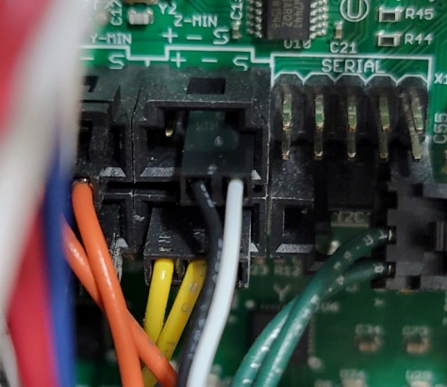

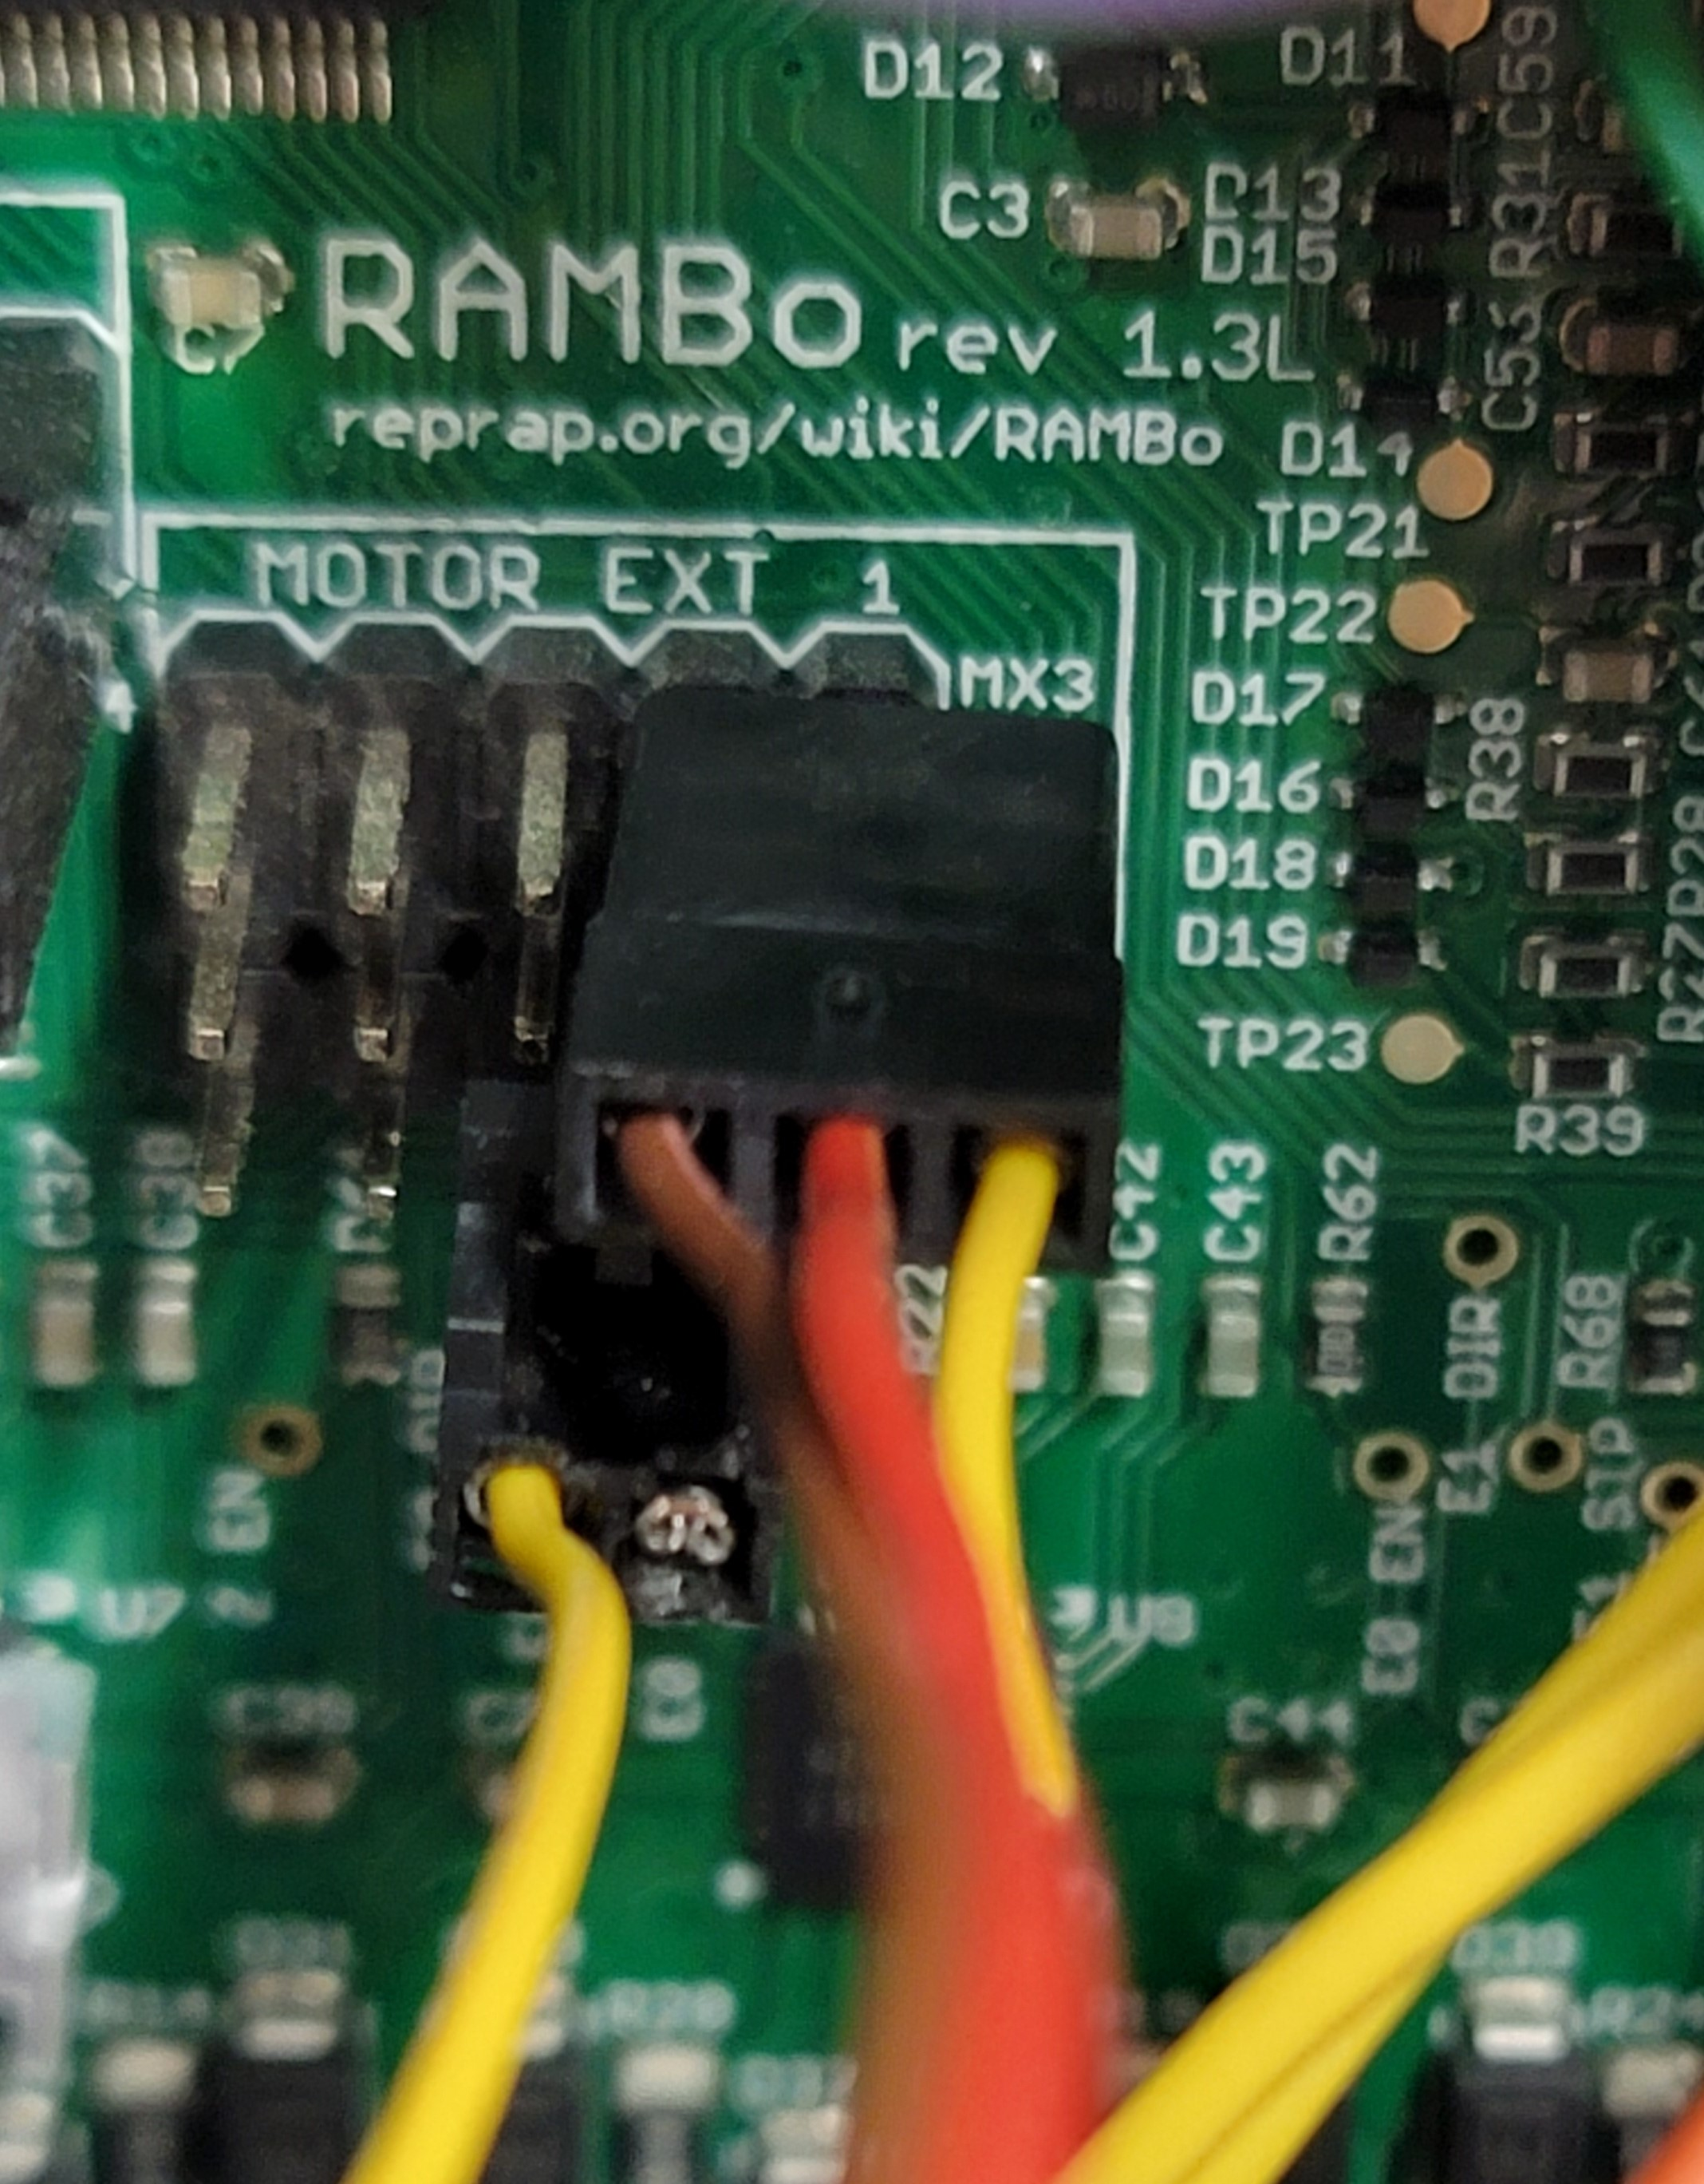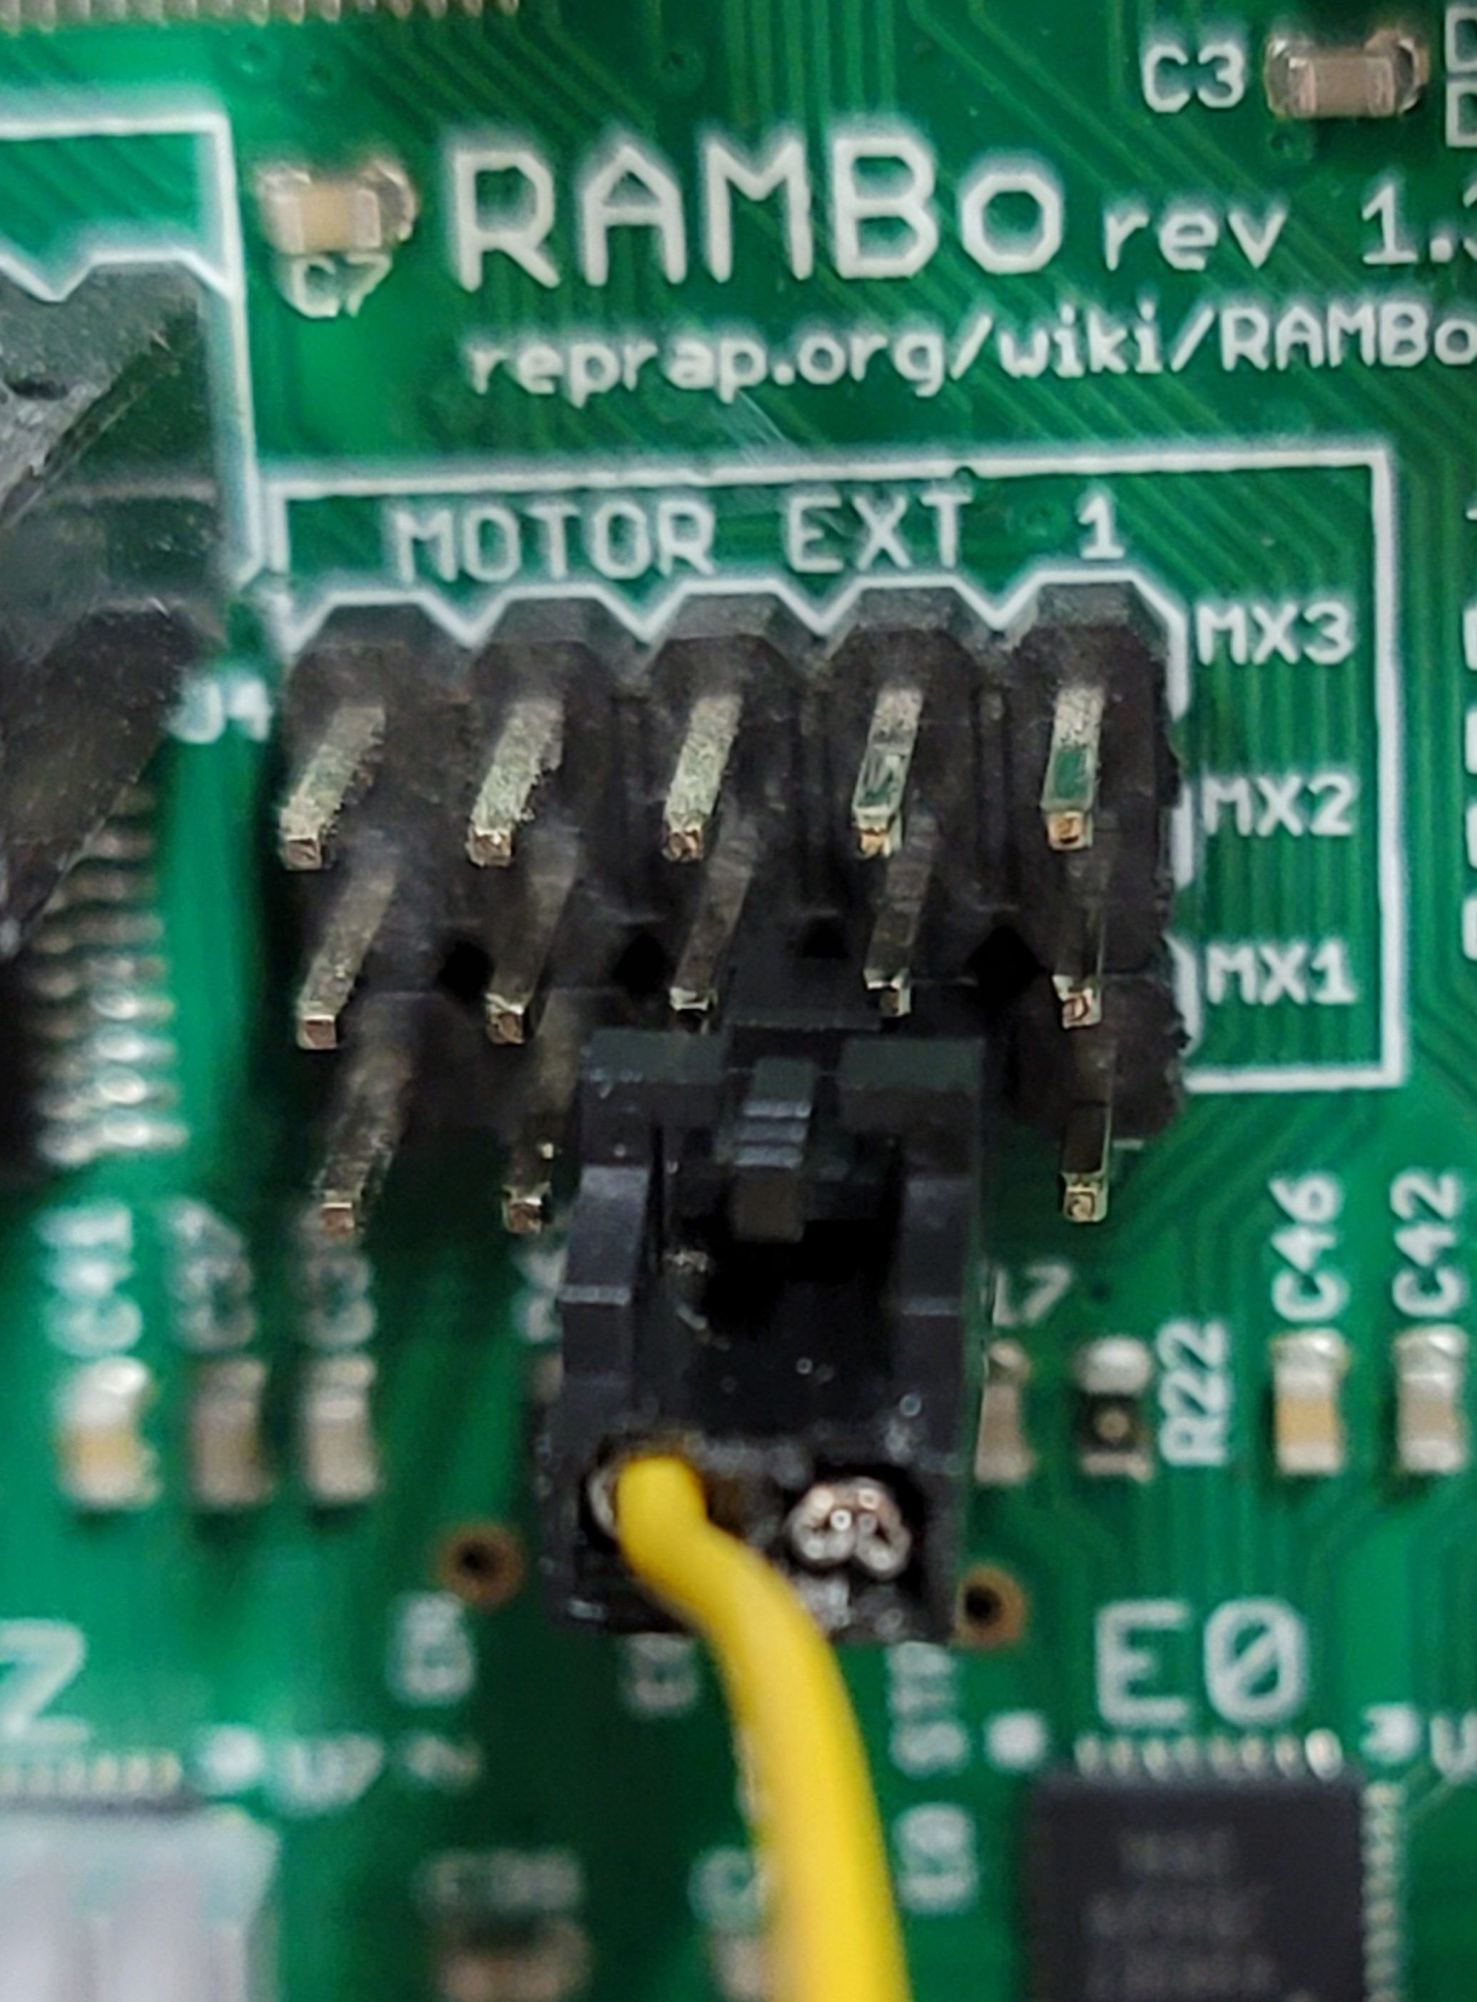

Button up all the wiring in the control box, and reinstall the interconnect cover. You can either add a new small section of wiring loom, or install it in to the current loom (it’s a bit tight already). If you add a new loom for the probe, just zip tie it to the existing toolhead harness all the way down to your toolhead. Re-install your toolhead and toolhead connector.

Next, you will need to remove your BTT Pad 7 from the box and find a suitable location for it next to your printer. It will require a power box to be plugged in so make sure you have enough plug-ins available at your printer location. When turning it on, you will want to go ahead and set your Wi-Fi up with your SSID and password. Once you set it setup. Go ahead and restart the touchpad, and bring up your Wi-Fi menu once again and it should show you the IP Address that has been designated.

You will need to download a program called Putty so that you can SSH into your Pad7. If you search for Putty Download, you should see it come up. Get it setup on your computer you will be using to talk to your Pad7. Open the Putty program and you will see a window with Host Name. Enter in btt-pad7 and the SSH button below should be checked. Click Open at the bottom of the window. A new screen will open up and ask you for a user and password. Both user and password are biqu/biqu. From there you will be logged into the pad7. Complete the following steps to build and flash the Klipper Firmware to your printer Main Board (Rambo). Be sure you have a USB cable attached from y our Pad7 to the TAZ printer. It will need to be connected from here on out.

**Type cd ~/klipper/**

**Type make menuconfig**

**Configure your settings according to the micro controller you are using.**

**Stock Rambo board (Taz 5, 6)**

**AVR atmega2560**

**or**

**Archim2 board (Taz6)**

**SAM3x8e**

**Type make**

**Plug in the printer via USB to pi and power it on.**

**Type ls /dev/serial/by-id/\***

**You printer should appear and look something like this. This is a unique ID and you'll need it later for the config file as well.**

**/dev/serial/by-id/usb-1a86_USB2.0-Serial-if00-port0**

**Now it's time to flash your board. Replace the ID with the one you got in the previous step.**

**Type sudo service klipper stop**

**Type make flash FLASH_DEVICE=/dev/serial/by-id/usb-1a86_USB2.0-Serial-if00-port0(this ID is just used for example, use the one provided in earlier steps)**

**Type sudo service klipper start**

**Reboot everything type sudo reboot**

You will need to use the ID that you got from these steps in your printer.cfg file that we provide so it can talk to your printer. You will copy and paste that into the printer.cfg file a bit later on. You can go ahead and close out of your Putty Config window.

You can now use the IP address that your Pad7 got earlier on in the Wi-Fi steps. Type it into your browser with your Pad7 turned on. You will see an error message for now, but please disregard this for the time being. Once you are logged into the PAD7 from your browser you will see a set of icons on the left side of your screen. Click the machine icon, and this will open up a window that will show your configuration files associated with the PAD7 and klipper. You will need to upload the files for this part of the install; printer.cfg, that has been provided to you. Once the printer.cfg uploaded, open the printer.cfg file and up top you will need to paste your **/dev/serial/by-id/\*** up top in the printer.cfg file so it can communicate with the board. You will need to go back to your Dashboard and then restart your firmware so it can communicate with the new build. The error that was on your screen should now be gone, and you should have a screen that shows homing, temperatures, etc.

The printer.cfg file is where the toolhead/stepper motor/printer info is stored. We have supplied you with files that you will need to rename to printer.cfg for them to work properly. You will need to be sure in the printer.cfg file, your toolhead does NOT have hash tags in front of each line. There should be a section for the stock toolhead, and a section for a Titan Aero toolhead. There you can set your filament diameter as well.

For setting your toolhead esteps you will be changing the Rotation distance on the [extruder] portion of the cfg file. Again, you will also see there is a setup for either the stock toolhead or a Titan Aero toolhead. If you are going to use the Titan Aero you will need put a hash in from of the stock extruder settings or vice versa, and remove the hash from the extruder you wish to use.

At this point make sure you X Axis is level across the bed meaning that you could run your nozzle across manually and it would be the same from the left side of the bed to the right. Turn your threaded rods until you can run it across and have it be the same on both sides. You can then click the Home button for each axis to ensure everything is working and moving as it should. X axis should home to the left side, the Y axis should home to the Back, and Z should go to the middle of the bed, and probe that location for Z. When you are homing each axis, be close to your printer on/off switch in case anything goes wrong.

Heat your bed up to at least 60C or whatever filament temp you are normally printing with. From your browser or the Pad7, you should be able to go into your height map menu or the config menu on the pad7 and go into bed mesh, and start the calibration. This will show you what your bed looks like and create a map for it to get the best first layer. In some cases you may need to shim your bed corners depending on what your first layer looks like if it can either compensate for it, or not. That will all depend on your bed. Again, be sure your X axis is level with the bed. It will give you the best possible starting point.

If you have specific Estep numbers saved from before, this is when you will change them. You can find a Estep to rotation distance convertor by searching online. Once you get that number you can replace it with the current rotation distance. You can check by telling the printer to extrude 100mm of filament and physically marking your filament at 100mm to ensure it send 100mm through it from the top at printing temperature.

We have the printer.cfg file setup to print a purge line at the front of the bed before it makes it over to your print. If you want this turned off, you can find the purge line in the cfg file, and put a hash in front of it to comment it out and not do the purge line.

**How to install the 1.75mm Filament Runout/Motion Sensor**

You will start by mounting your filament runout sensor in whichever configuration you want to run your filament with. We have provided a bracket for both top side configuration and a Top only configuration. See pics below for how we mounted our 1.75mm runout sensor. If you want to create your own bracket, reach out to us we can provide you with a STEP file to create your own based on your needs.

We have pinned your filament runout sensor so all you have to do is put the connectors to their correct locations. Red will go into pin 1, black on pin 2 Blue on Pin 7 of the X40 Connector. Green will do to Pin 5 on the X34 connector. SEE PICS FOR LOCATIONS.

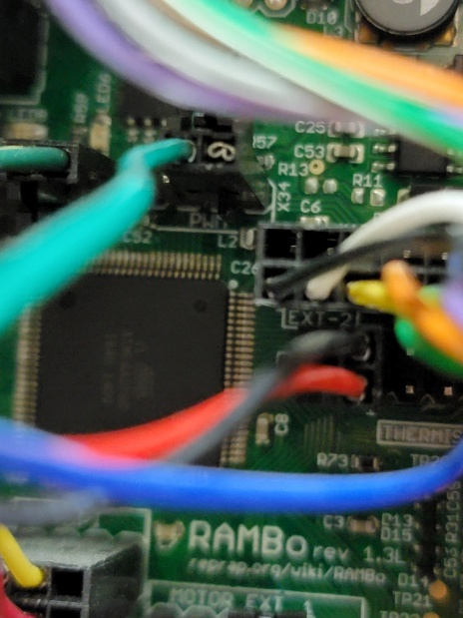 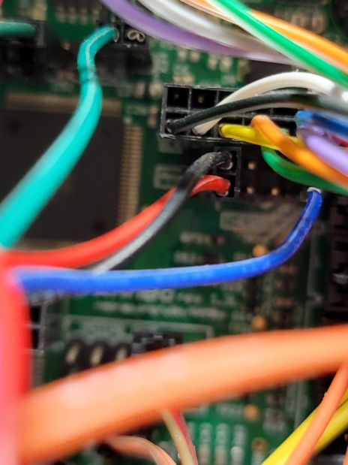

We have showed the connections with the Rambo 1.3L Main Board. These same instructions will work for the 1.4 as well, but one connector location is a bit different. You will need to locate the X34 and X 40 connectors. The X34 set is a 6 pin in line configuration just above the largest main chip on the board. The X 40 is over to the right side of the largest chip on the board.

Keep in mind, the filament run-out/motion sensor will only work with 1.75mm filament. Now would be a great time to upgrade to a 1.75mm toolhead if you don’t already have one. We offer a wide range of 1.75mm toolheads. Toolhead that flow more and can keep up with higher speeds can be beneficial here. CHT nozzles as well as things like REVO HF can help out with that as well.

**How to install the 2.85mm Filament Runout Switch**

The 2.85/3mm sensor will install into some of the same pins as the 1.75mm, so if you are using the 2.85mm just swap the connectors for the pins shown in the photos below. You will be using Pin 2 for the black wire, and pin 7 for the red wire of the X40 Connector.

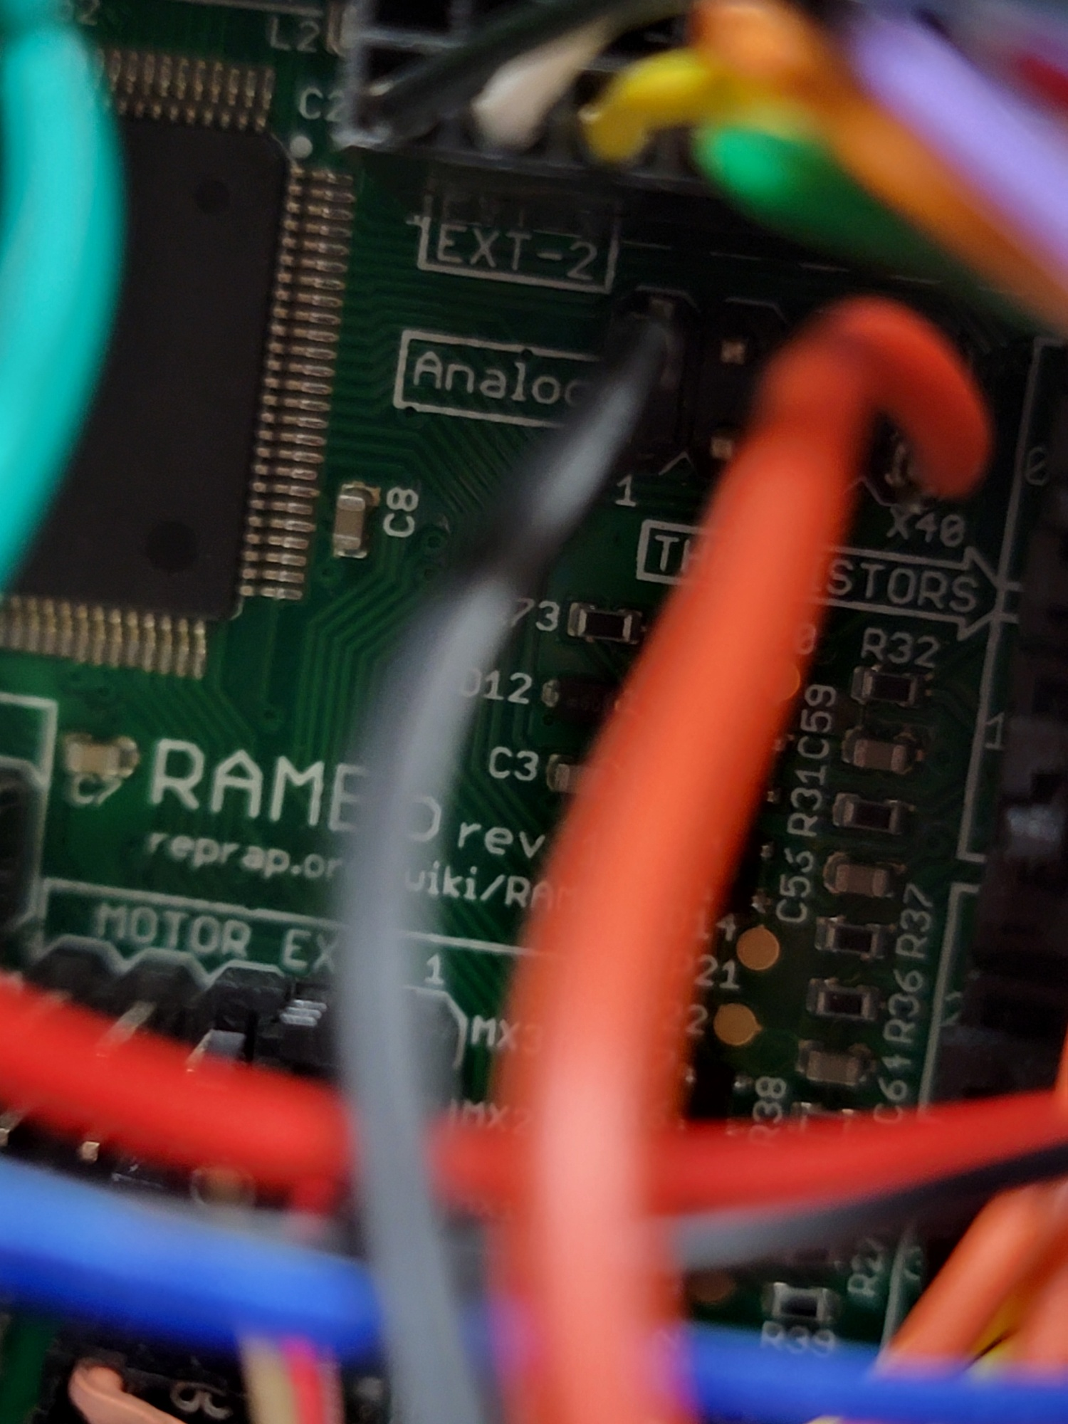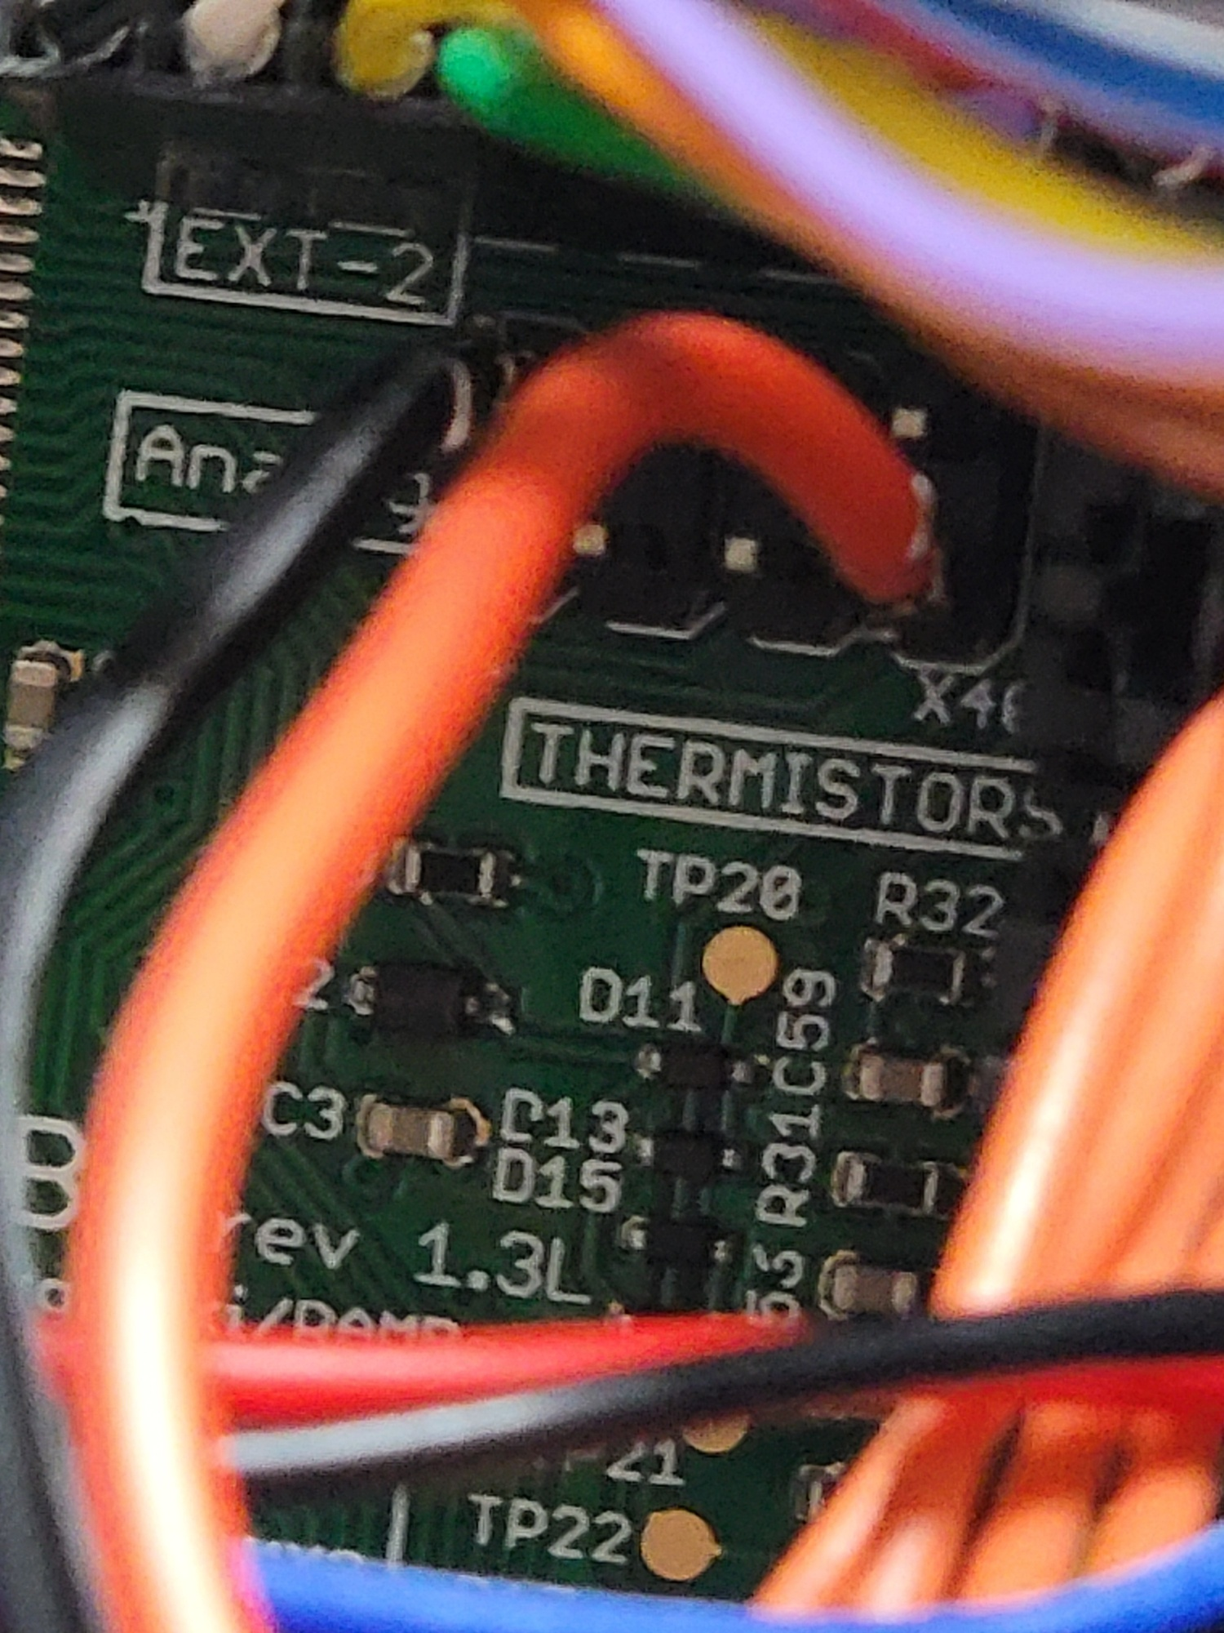

**HOW TO SETUP AND USE THE ADXL345 FOR INPUT SHAPER**

We have already added the file necessary to use the ADXL345 provided with the PAD7. We have also added the necessary config tags into the printer.cfg file and adxl.cfg file that is necessary to work.

Start with the units power off, plug the adxl345 harness into the sensor itself, and then into the Pad7. To run input shaper on the y axis you will need to remove your wiper pad from the Y axis. You can use one of the screws to mount your adxl sensor to the bed plate. Make sure your wiring can move to the and have it not overextend or get caught anywhere. You will need to go into your printer.cfg file and remove the # from [include adxl.cfg]. Go into your console and run the following command: accelerometer_query. You should get a reading if working as it should. Home all axis, then you will type in shaper_calibrate axis=y. It will run a series of resonance tests. Once it’s finished up, it will show you the results, and ask you to save config. Go ahead and save, then restart Klipper and let it come back up to the dashboard. Go back into your printer.cfg file, and then scroll down to the very bottom. You should see those results posted there. Now you will be the same for your X axis. Attach the adxl to your toolhead somewhere, we mounted ours to one screw on the fan. Run the test again, and save like before. Save config and go back into your printer.cfg file and scroll to the bottom again and see if it saved those settings. If so you are done with input shaping. Keep in mind you will be required to do any tuning to your printer. We will not provide profiles for anything. Input shaping can only help so much so be sure to perform any calibration prints as necessary to get the best possible prints.